Netflix Clone CI-CD with Terraform |Kubernetes| Monitoring | Email
Hello there, buddies. We will set up a Netflix clone. We will be use Terraform to provision an EC2 instance with Kubernetes, Jenkins, Docker, SonarQube Container, Trivy, Prometheus & Grafana. Using Jenkins as a CICD tool, we deploy our application on a Docker container and a Kubernetes cluster, and we monitor Jenkins and Kubernetes metrics with Grafana, Prometheus, and Node exporter. I hope you found this informative blog useful.
Terraform to provision : Jenkins, Docker, SonarQube Container, Trivy, Prometheus & Grafana
https://github.com/surajpjoshi/Terraform_Netflix.git
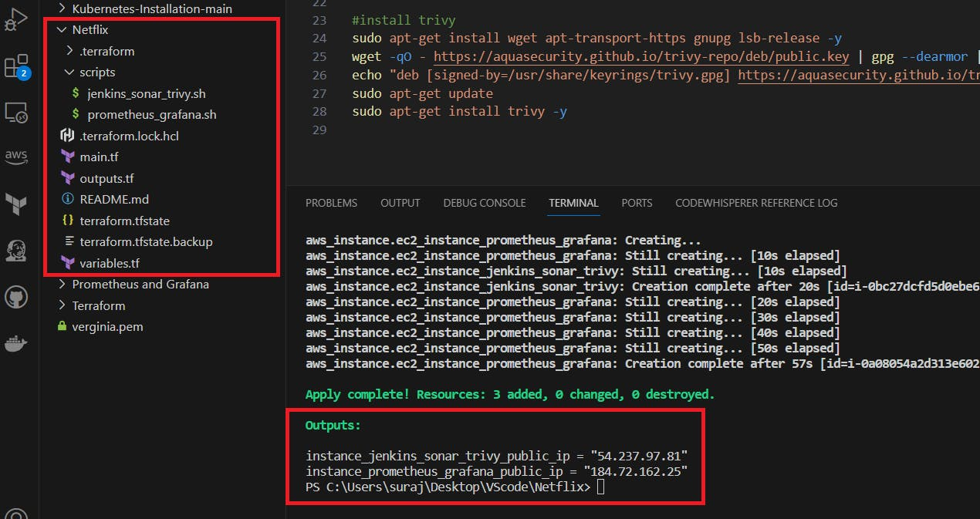
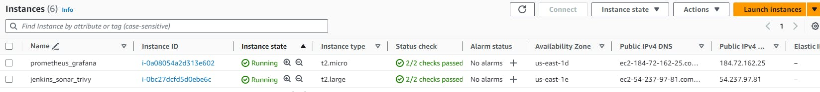
Terraform to provision : kubernetes
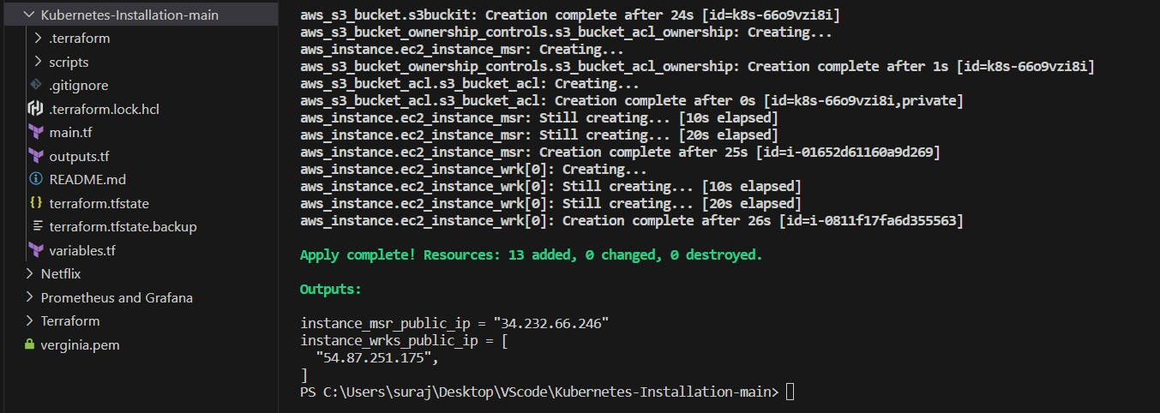
Jenkins : http://54.237.97.81:8080/
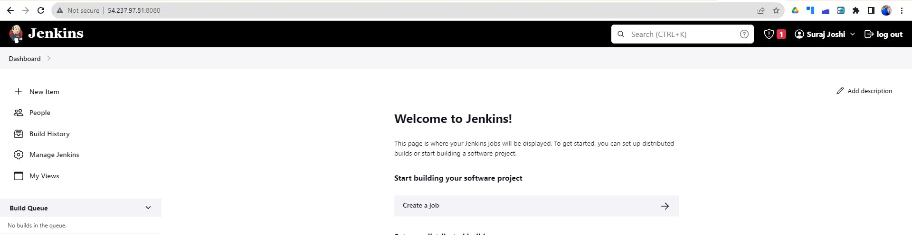
Sonarqube : http://54.237.97.81:9000/
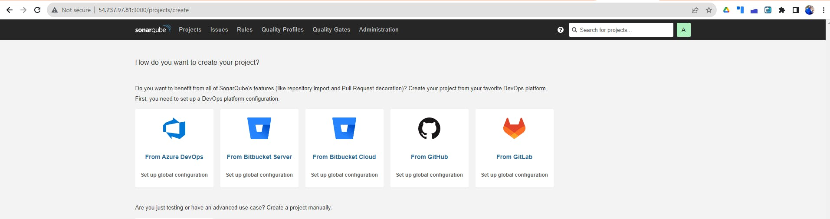
Prometheus :
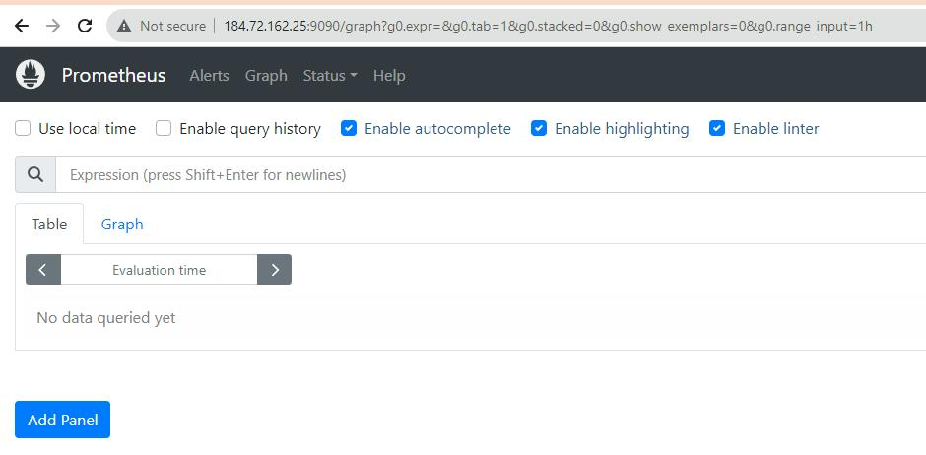
Grafana:
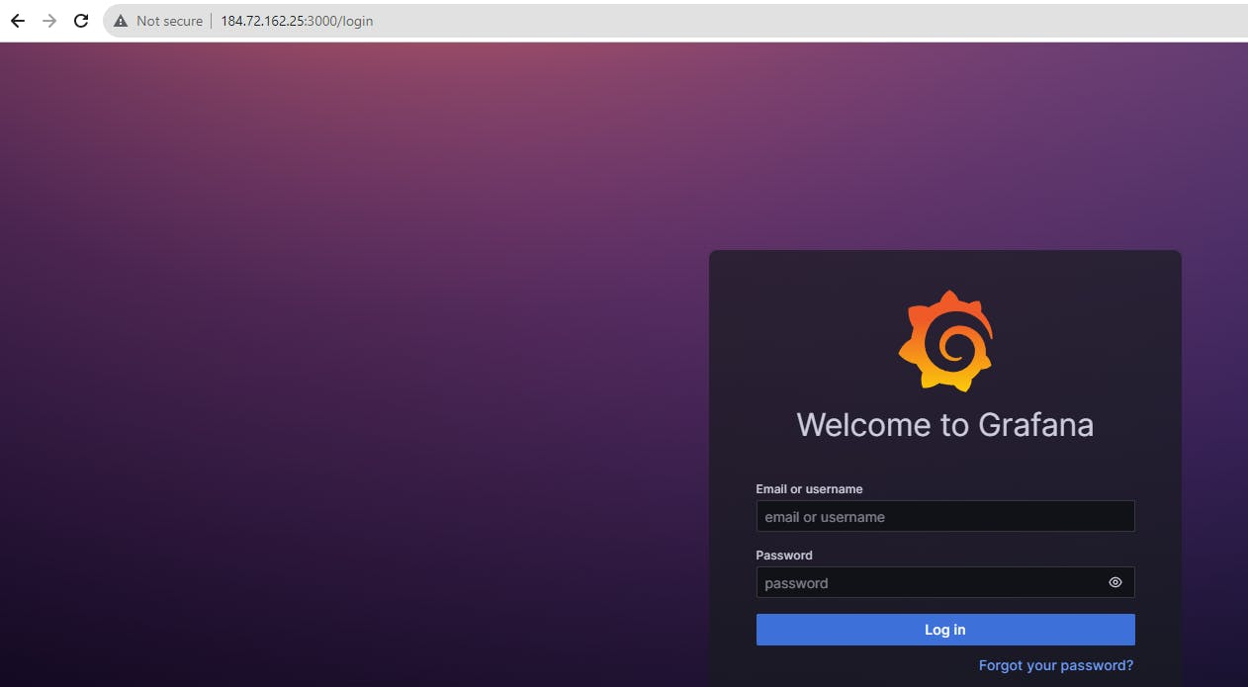
CICD Pipe Line:
COPY
COPY
pipeline{
agent any
tools{
jdk 'jdk17'
nodejs 'node16'
}
environment {
SCANNER_HOME=tool 'sonar-scanner'
}
stages {
stage('clean workspace'){
steps{
cleanWs()
}
}
stage('Checkout from Git'){
steps{
git branch: 'main', url: 'https://github.com/surajpjoshi/Netflix-clone.git'
}
}
stage("Sonarqube Analysis "){
steps{
withSonarQubeEnv('sonar-server') {
sh ''' $SCANNER_HOME/bin/sonar-scanner -Dsonar.projectName=Netflix \
-Dsonar.projectKey=Netflix '''
}
}
}
stage("quality gate"){
steps {
script {
waitForQualityGate abortPipeline: false, credentialsId: 'Sonar-token'
}
}
}
stage('Install Dependencies') {
steps {
sh "npm install"
}
}
stage('OWASP FS SCAN') {
steps {
dependencyCheck additionalArguments: '--scan ./ --disableYarnAudit --disableNodeAudit', odcInstallation: 'DP-Check'
dependencyCheckPublisher pattern: '**/dependency-check-report.xml'
}
}
stage('TRIVY FS SCAN') {
steps {
sh "trivy fs . > trivyfs.txt"
}
}
stage("Docker Build & Push"){
steps{
script{
withDockerRegistry(credentialsId: 'docker', toolName: 'docker'){
sh "docker build --build-arg TMDB_V3_API_KEY=2cffc1b7f9a2451e1c357eeb211c45d2 -t netflix ."
sh "docker tag netflix surajpjoshi/netflix:latest "
sh "docker push surajpjoshi/netflix:latest "
}
}
}
}
stage("TRIVY"){
steps{
sh "trivy image surajpjoshi/netflix:latest > trivyimage.txt"
}
}

stage('Deploy to kubernets'){
steps{
script{
dir('Kubernetes') {
withKubeConfig(caCertificate: '', clusterName: '', contextName: '', credentialsId: 'k8s', namespace: '', restrictKubeConfigAccess: false, serverUrl: '') {
sh 'kubectl apply -f deployment.yml'
sh 'kubectl apply -f service.yml'
}
}
}
}
}

}
post {
always {
emailext attachLog: true,
subject: "'${currentBuild.result}'",
body: "Project: ${env.JOB_NAME}<br/>" +
"Build Number: ${env.BUILD_NUMBER}<br/>" +
"URL: ${env.BUILD_URL}<br/>",
to: 'surajpjoshi@gmail.com',
attachmentsPattern: 'trivyfs.txt,trivyimage.txt'
}
}
}
Build Pipe Line:
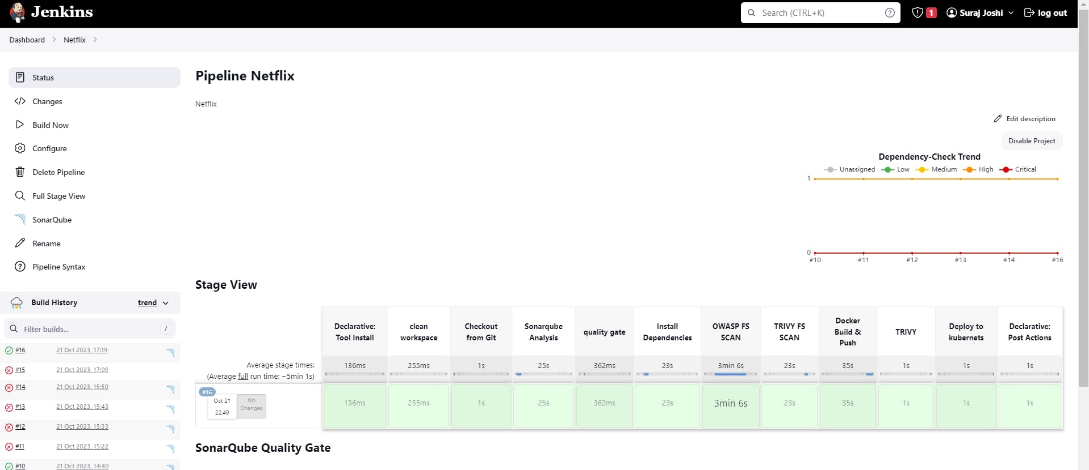
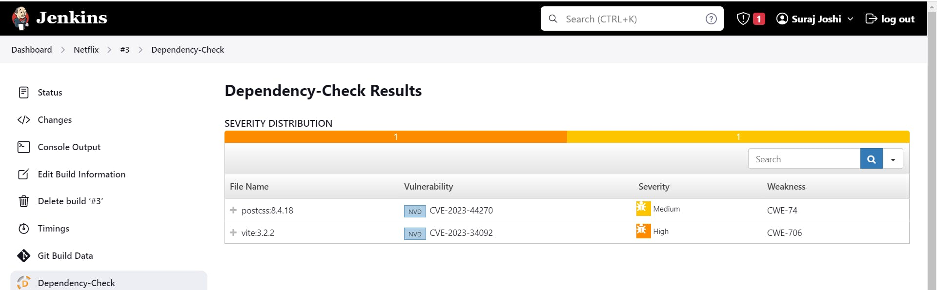
Finally : http://54.87.251.175:30007
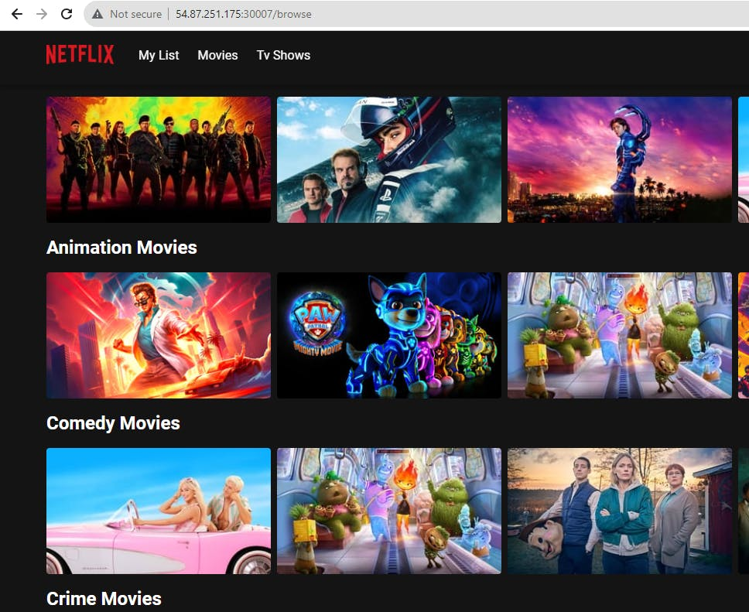
Email Notification :
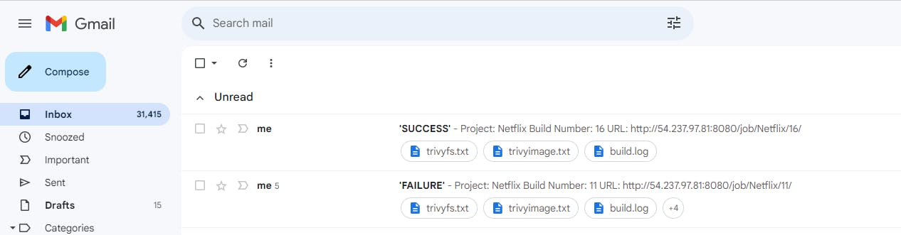
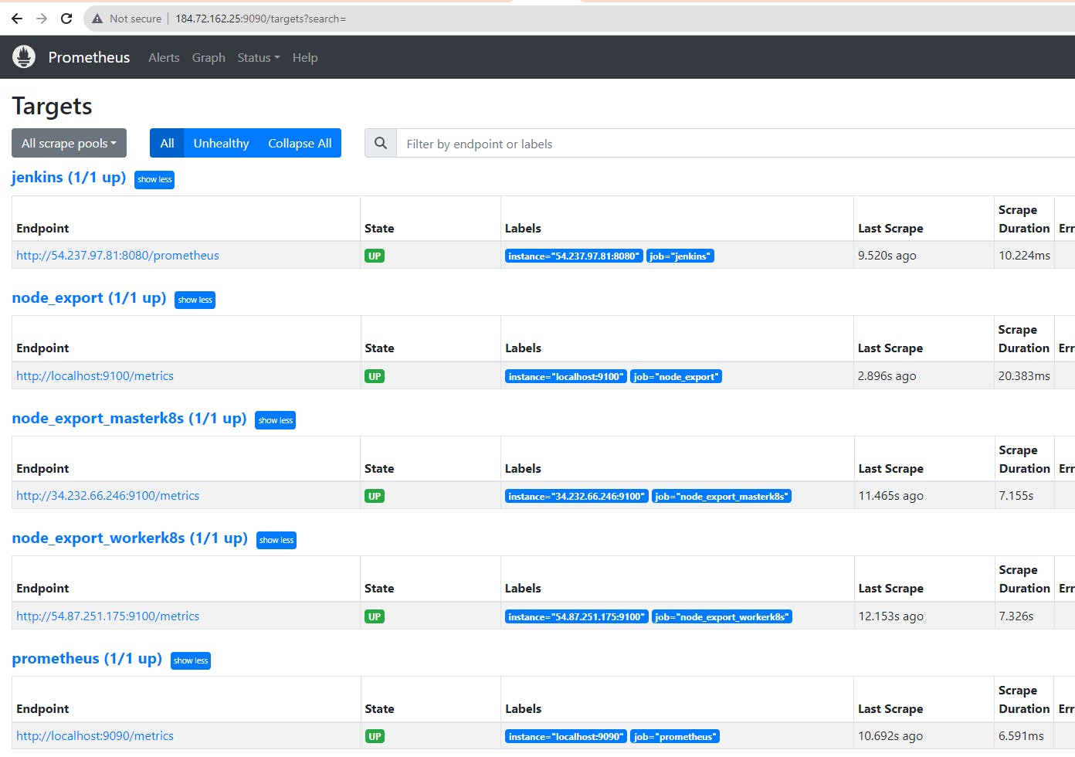
Monitoring master & node on Grafana dashboard :
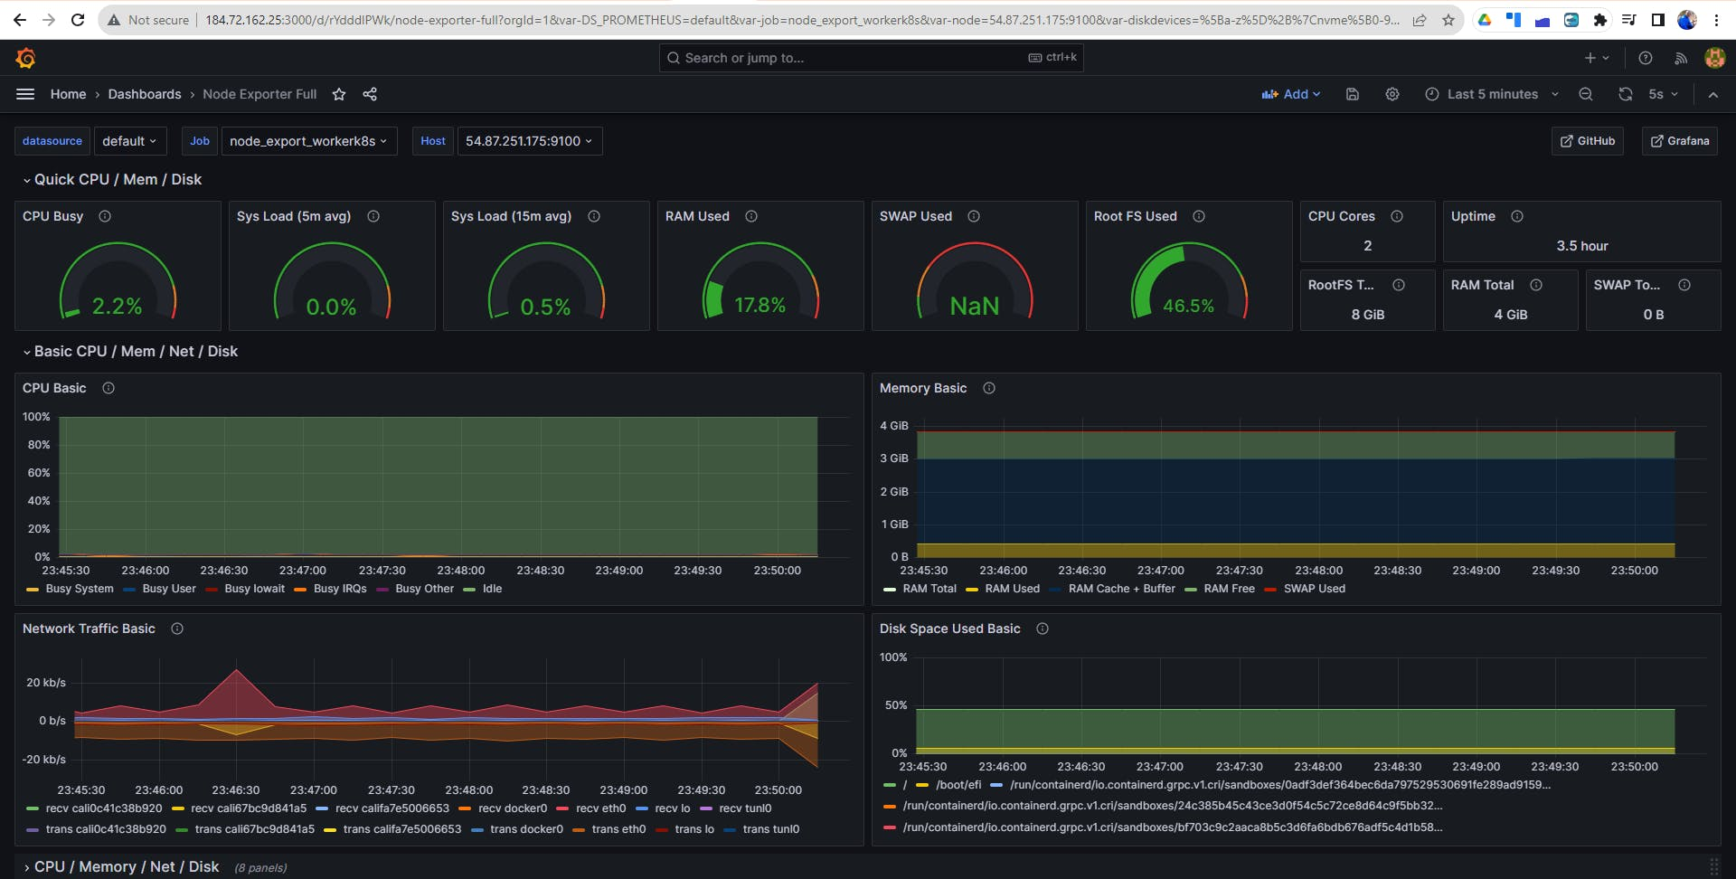
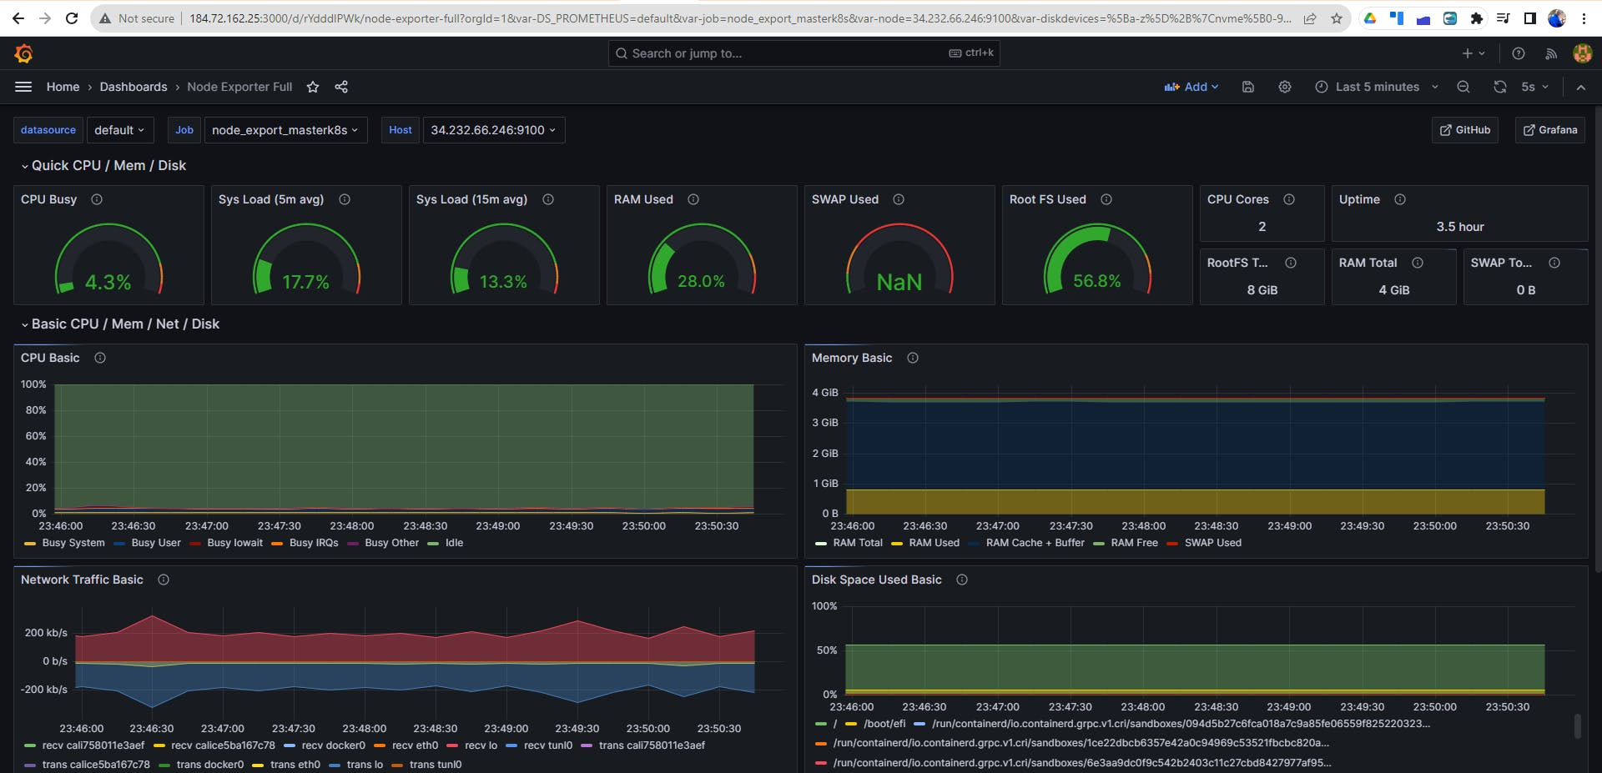
Finally, after taking a deep dive into the realm of devops and learning a lot..
COPY
COPY
terraform destroy
